Link:[**http://www.studytonight.com/computer-networks/unbounded-transmission-media**](http://www.studytonight.com/computer-networks/unbounded-transmission-media)

**Replace** the content **Before** the two types of Micro Waves with this :

**Micro Waves:**

Electromagnetic waves having frequencies between 1 and 300 GHz are called micro waves. Micro waves are unidirectional. When an antenna transmits microwaves, they can be narrowly focused. This means that the sending and receiving antennas need to be aligned. The unidirectional property has an obvious advantage. A pair of antennas can be aligned without interfering with another pair of aligned antennas.

The following describes some characteristics of microwaves propagation:

* Microwave propagation is line-of-sight. Since the towers with the mounted antennas need to be in direct sight of each other, towers that are far apart need to be very tall.
* Very high-frequency microwaves cannot penetrate walls. This characteristic can be a disadvantage if receivers are inside the buildings.
* The microwave band is relatively wide, almost 299 GHz. Therefore, wider sub-bands can be assigned and a high date rate is possible.
* Use of certain portions of the band requires permission from authorities.

Unidirectional Antenna:

Microwaves need unidirectional antennas that send out signals in one direction. Two types of antennas are used for microwave communications: the parabolic dish and the horn.

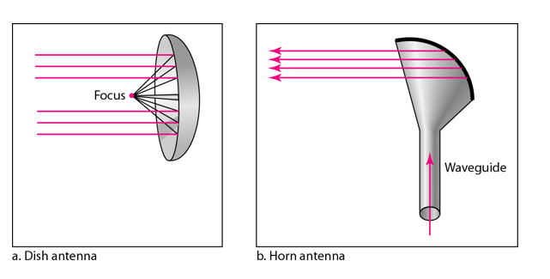

A parabolic antenna works as a funnel, catching a wide range of waves and directing them to a common point. In this way, more of the signal is recovered than would be possible with a single-point receiver.

A horn antenna looks like a gigantic scoop. Outgoing transmissions are broadcast up a stem and deflected outward in a series of narrow parallel beams by the curved head. Received transmissions are collected by the scooped shape of the horn, in a manner similar to the parabolic dish, and are deflected down into the stem.

**Applications:**

Microwaves, due to their unidirectional properties, are very useful when unicast (one-to-one) communication is needed between the sender and the receiver. They are used in cellular phones, satellite networks and wireless LANs.

**Then continue with the existing content as it is:**

There are 2 types of Microwave Transmission :